**Guided Capstone Project Report - Big Mountain Resort**

**Overview**

Big Mountain Resort’s goal is to raise revenue, either by raising ticket prices or lowering operating costs. Big Mountain would like to evaluate whether their tickets are appropriately priced compared to other resorts in their market share and identify the features that have the most impact on resort ticket prices and use this information to inform their pricing strategy.

**Important Factors for Ticket Price**

The evaluation process began with exploratory data analysis, during which fastQuads, Runs, Snow Making_ac, resort_night_skiing_state_ratio, total_chairs, and vetical_drop were identified as the most important features for determining ticket price. After further analysis, a random forest model was selected for further use. This model identified fastQuads, Runs, Snow Making_ac, and vertical_drop as the most important factors for setting ticket price, consistent with preliminary findings from exploratory data analysis. The figure below shows the final model’s ranking of feature importance.

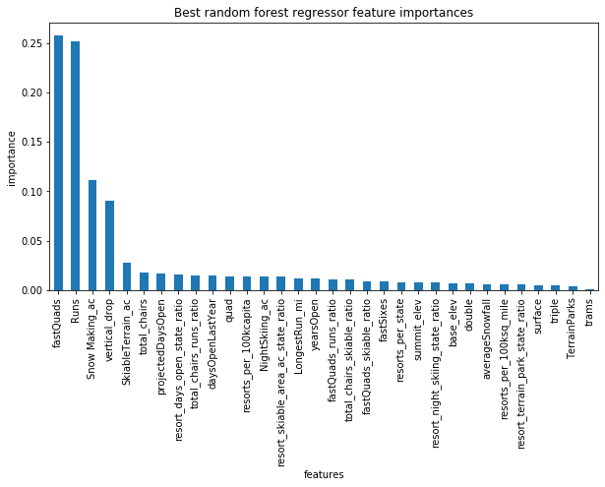

Big Mountain’s features compare favorably to the other resorts in its market share. In fact, for each of the top four features, Big Mountain’s facilities ranked better than at least 89% of the other resorts in the market share.

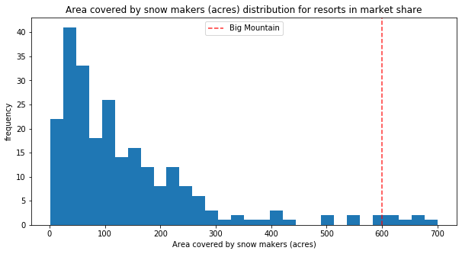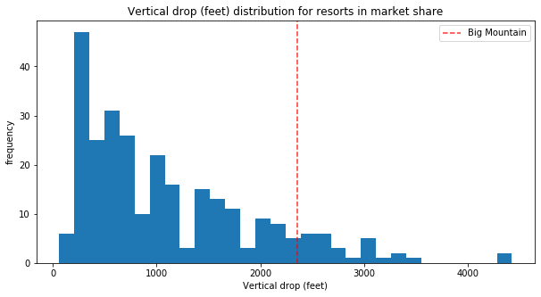

Because Big Mountain’s features compare favorably to those of other resorts, the model predicted Big Mountain’s ticket price as $94.22, suggesting Big Mountain could charge more than its current $81.00 price. 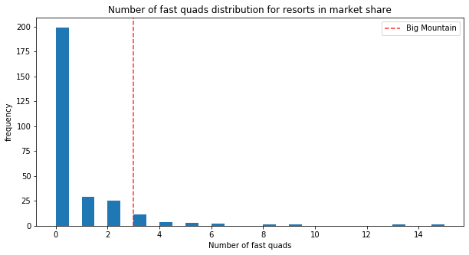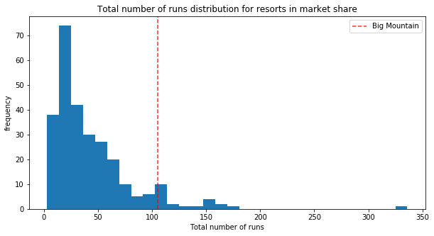

**Recommended Course of Action**

The model’s error of $10.39 indicates that, at the lowest, Big Mountain could support a ticket price of $83.83. Big Mountain should raise the ticket price, even if only by $2.50. Big Mountain should also consider two additional courses of action:

1. Option 1: Adding a run with a lower end, thus increasing vertical drop, and installing an additional chair lift. The model indicates that this option would enable Big Mountain to increase ticket prices an additional $1.99, generating an additional $3,474,638 a year. This increase would cover the additional $1,540,000 in chair lift operating costs.
2. Option 2: Closing at least one of the least-used runs. Modeling Big Mountain with one less indicates that ticket price would not drop. Closing a run would save Big Mountain money on maintenance costs for the least-used run, thereby raising revenue. Big Mountain could consider closing additional runs, but these closures will drop ticket price. Whether or not this is an advantageous decision depends on the maintenance costs of the runs. If the saved maintenance costs will be more than the money lost from lowering ticket prices, Big Mountain might consider closing more runs.

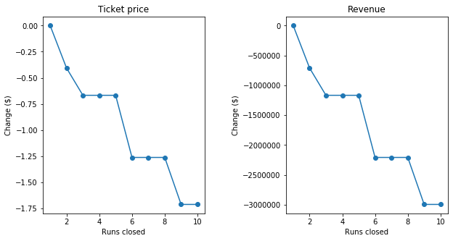

**Additional Considerations**

Big Mountain will need to consider the up front costs of any additional runs and chair lifts. If the cost to build these new facilities is high, they might not be worth the additional revenue they will bring in. Big Mountain should also consider how much they would like to raise ticket prices from the $81.00 to the $94.22 the model suggests they could charge. If their customer base is mostly customers that return each year, a larger increase in ticket price could potentially deter them. Both of these considerations are outside the current scope of data provided.